To: |  | Quote No:  Job No:
Company:
 |  | Contents:
 |  | Page 1: | Product Image and Price
 |  | Page 2: | Technical Specification
 |  | Page 3: | Technical Drawings
 |  | Page 4: | Colour Options & Example
 |  | Page 5: | Optional Extras
Date:

1 of 5. Product Image and Price

Quote to supply only the Simplicity Xtra Veranda System with a 10-year guarantee as per specifications and installation information outlined on page 2.

Canopy Size: <Canopy Length> metres X <Canopy Projection> metres

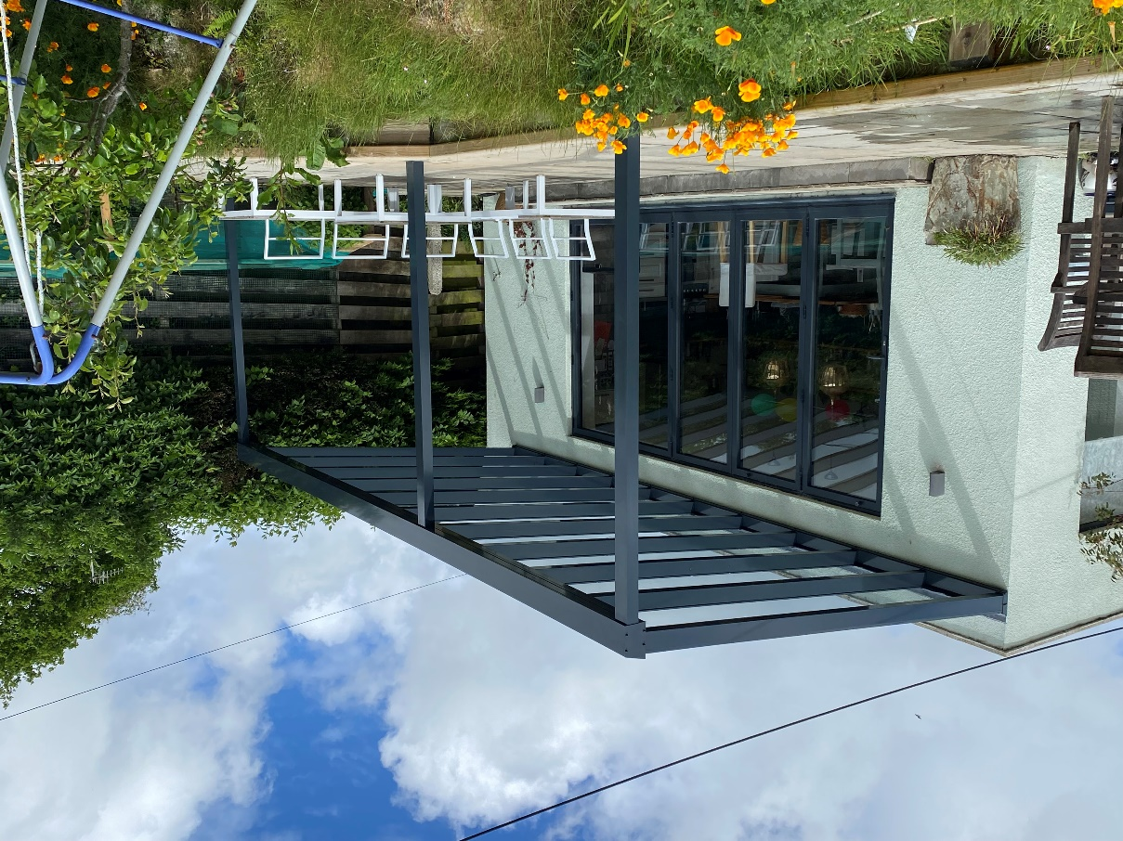 |   

Total cost: £ + VAT
Payment terms:

 | 2 of 5. Technical Specification
Item |  | Technical Specification
Roof Panels |  | The canopy is glazed with 6mm toughened glass. This provides high light transmission for outstanding visual clarity when an unrestricted view is required.
Posts |  | Posts are made from 100mm x 70mm aluminium box section. You can also have 70mm x 75mm and 70mm x 70mm.
Framework |  | Aluminium framework is finished in a choice of Black or Anthracite Grey as standard, however at an additional cost the framework can be powder coated to any RAL colour.
Weather resistance |  | All structural components are made from aluminium for ultimate strength and total weather resistance.
Method of fixing |  | Back plate is fixed to wall/fascia, posts are fixed in ground.  Please note: If your building control or planning officer requires additional foundation mass or rainwater drainage over and above what has been quoted for this will be at an additional cost to you. The Simplicity Xtra roof structure is classed as fragile and therefore is not safe to be walked on as a means of escape.
Guttering & downpipes |  | Integral aluminium guttering as standard, downpipes to be uPVC
Underground drainage |  | Please review our terms and conditions.
Code 3 Lead flashing |  | Lead flashing will be used wherever possible to seal the back of the carport. However, this is usually only possible where we can cut a groove into the material on which the carport will be fixed. On all other installations including fixing the back-plate across windows, “Flash-band” or “silicon sealant” may be used and in this case we cannot guarantee a watertight seal.
Guarantee |  | The Simplicity Xtra is supplied with a 10 year guarantee.
Life expectancy |  | Up to 25 years’ life expectancy depending on geographical locations and subject to the Milwood Group Maintenance Schedule.

Please note:
- The height at the back of the veranda is a maximum of 3.5 metres
- The height at the front of the veranda is a maximum of 2.4 metres
- Please note the minimum pitch of a system using self-cleaning glass needs to be a minimum of 10°
- At 4 metres projection (maximum glass length) the maximum pitch of your roof system is 22.5° due to glass length, contact the office for further details
- It is the customer’s responsibility to arrange for the removal of any items that may obstruct the carport unless prior arrangement has been made with us.
- It is the customer’s responsibility to check whether planning permission and building regulations are required.
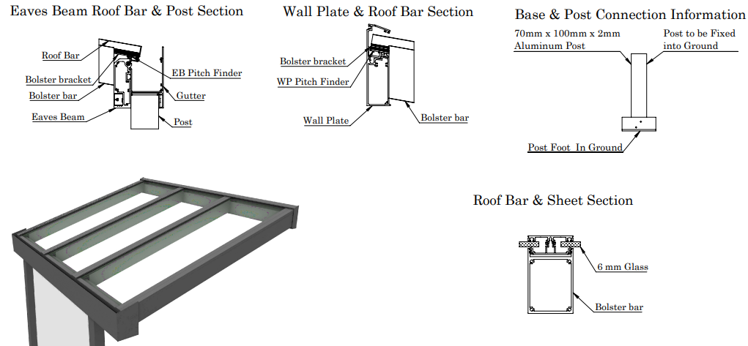

3 of 5. Technical Drawings

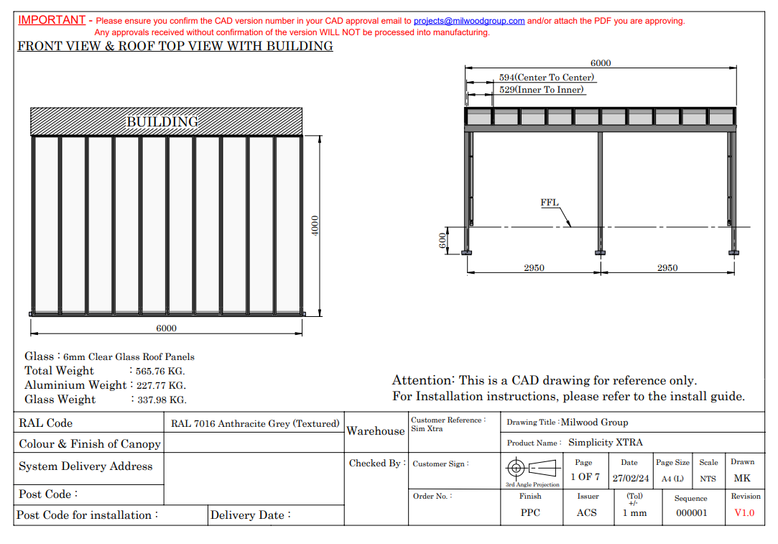

4 of 5. Colours Options
RAL Colour Options

The Simplicity Xtra aluminium frame is supplied in a choice of Black or Anthracite Grey as standard however, they can also be finished in any RAL Colour to match existing window and door frames or outdoor furniture at an additional cost.

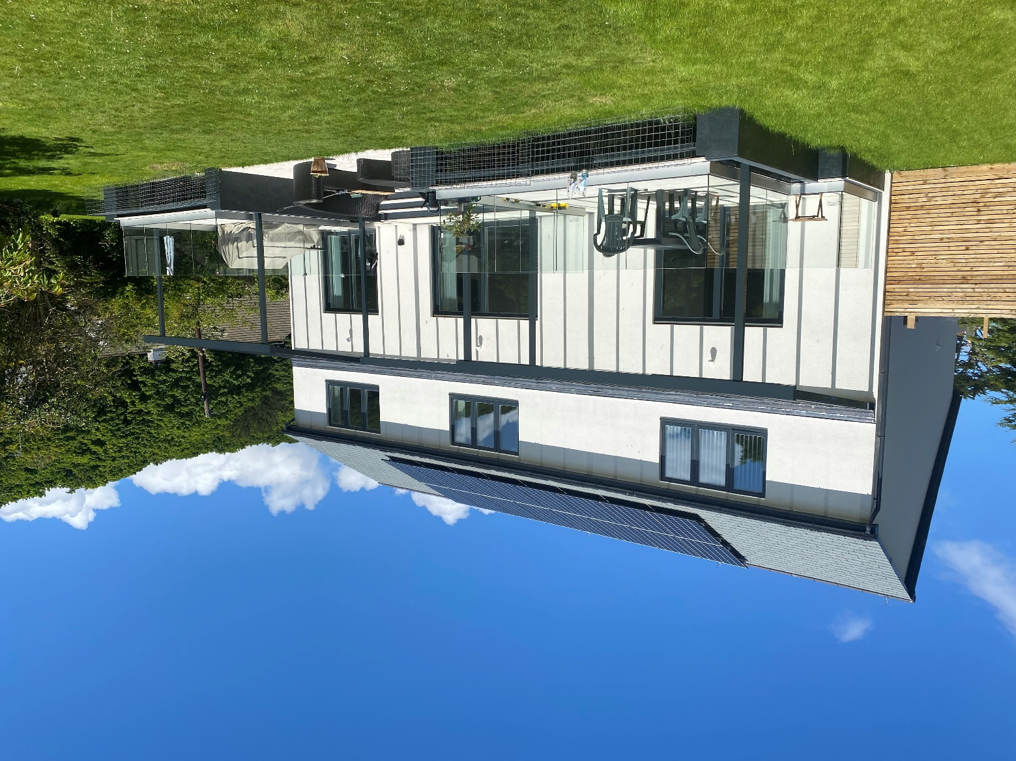
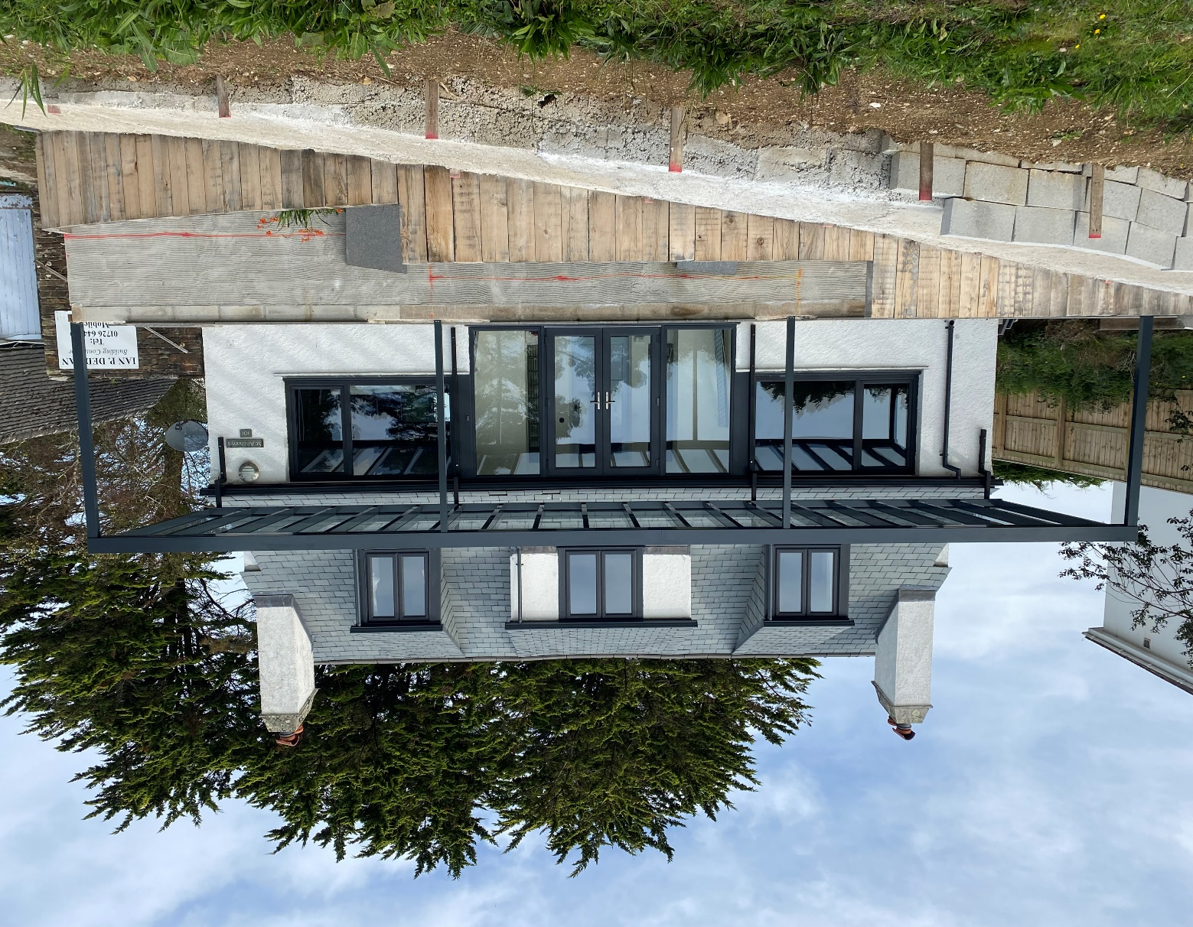

5 of 5. Optional Extras

The Victorian Upgrade

The Victorian Upgrade can be added to the Simplicity Xtra at an additional cost. This ornate upgrade consists of decorative, Victorian style post coverings that would fit in perfectly with traditional style buildings.

The Simplicity Xtra can be transformed into a vintage canopy or carport with these ornamental post coverings which are manufactured from high grade aluminium to match the Simplicity Xtra frame.

To have Victorian upgrades you need to have 75mm x 70mm posts.

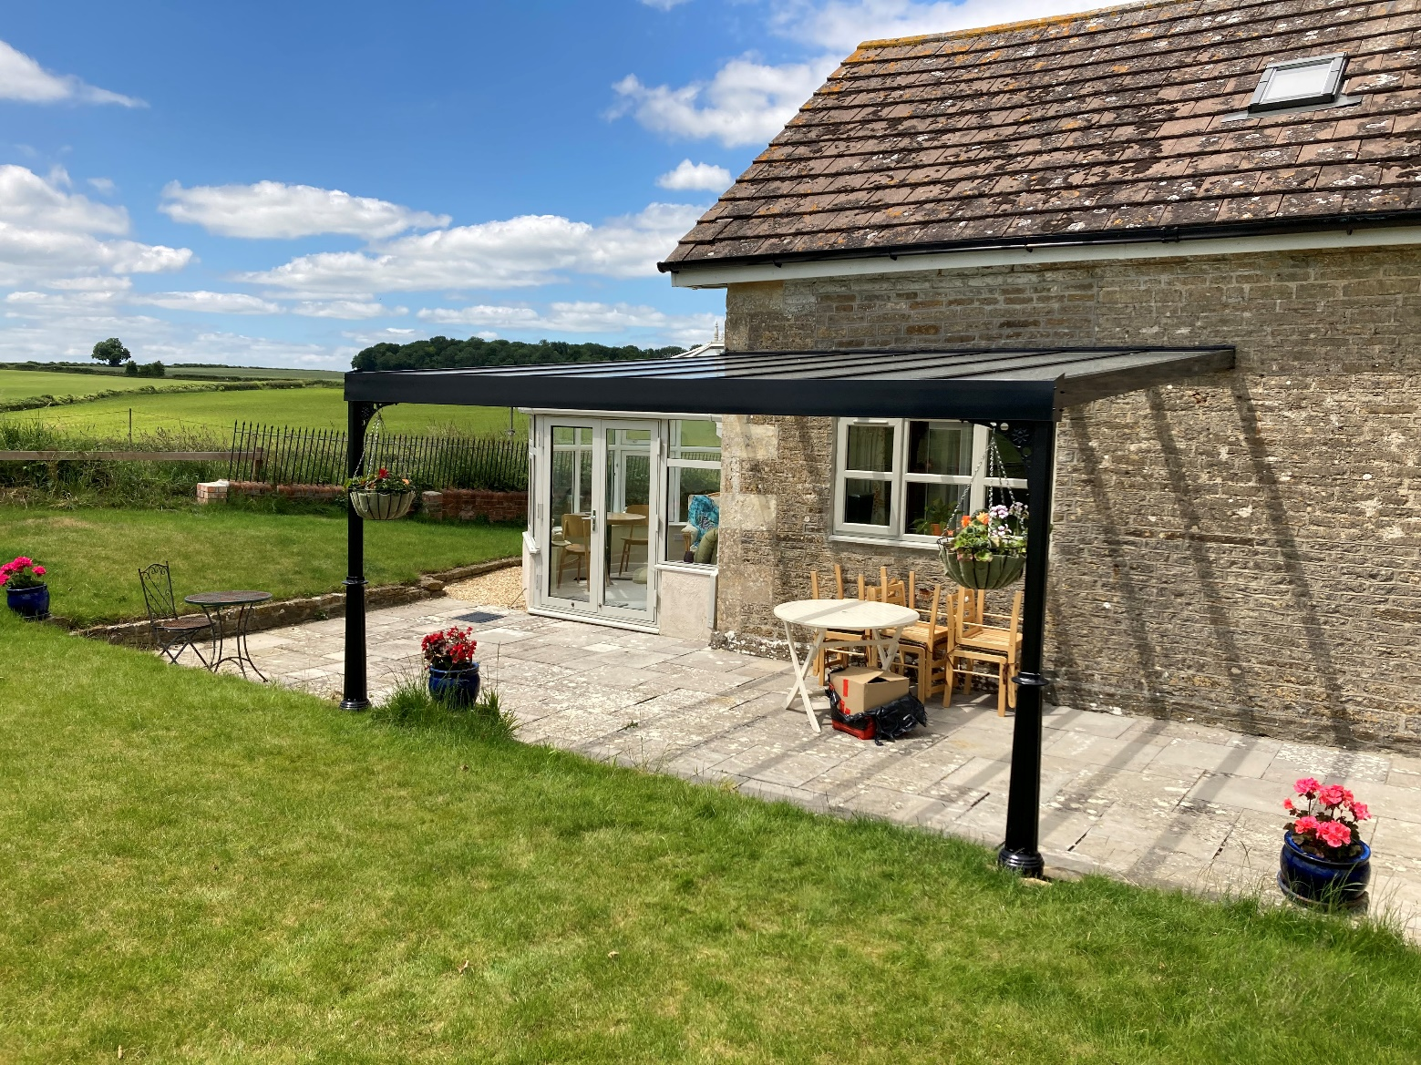

Heaters & Lighting

Our Spotlighting Upgrade is only available for Sim Xtra and Sim Free models at a competitive price and must be installed by a qualified electrician to ensure they are fully operational and compliant.

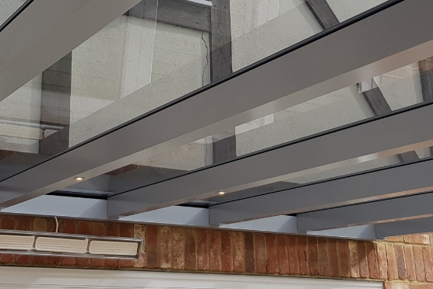

The infrared wall mounted heaters have ceramic elements that are designed to gently warm adults and children whilst outdoors under a covered structure such as a canopy using Far Infrared technology which is completely harmless and contains no ultraviolet radiation or fumes. Freestanding options are also available.

