|  |  |  |  |
| --- | --- | --- | --- |
| **To:** |  | **Quote No:**  **Job No:** |  |
|  |  |  |  |
| **Company:** |  |  |  |
|  |  | **Contents:** |  |
|  |  | **Page 1:** | Product Image and Price |
|  |  | **Page 2:** | Technical Specification |
|  |  | **Page 3:** | Technical Drawings |
|  |  | **Page 4:** | Colour Options & Example |
|  |  | **Page 5:** | Optional Extras |
| **Date:** |  |  |  |

**1 of 5. Product Image and Price**

Quote to supply only the **Simplicity 6 Canopy System** with a 10-year guarantee as per specifications and installation information outlined on page 2.

**Canopy Size :** <Canopy Length> metres X <Canopy Projection> metres



|  |  |
| --- | --- |
| https://s3-eu-west-1.amazonaws.com/milwood/high-res-images/Simplicity+6/cp-interiors-simplicity-6+02.JPG |  |



**Total cost : £ + VAT**

**Payment terms:**

|  |  |  |  |
| --- | --- | --- | --- |
| **2 of 5. Technical Specification** | |  |  |
| **Item** | | **Technical Specification** | | | |
| **Roof Panels** | | The canopy is glazed with 6mm toughened glass. This provides high light transmission for outstanding visual clarity when an unrestricted view is required. | | | |
| **Posts** | | Posts are made from 75mm x 70mm Standard Posts or 70mm x 70mm Square Posts or 100mm x 70mm for a more chunkier look. | | | |
| **Framework** | | Aluminium framework is finished in white semi-gloss, anthracite grey fine textured and black fine textured as standard, however at an additional cost the framework can be powder coated to any RAL colour. | | | |
| **Weather resistance** | | All structural components are made from aluminium for ultimate strength and total weather resistance. | | | |
| **Method of fixing** | | Back plate is fixed to wall/fascia, posts are fixed in ground.**Please note:** If your building control or planning officer requires additional foundation mass or rainwater drainage over and above what has been quoted for this will be at an additional cost to you. The Simplicity 6 roof structure is classed as fragile and therefore is not safe to be walked on as a means of escape. | | | |
| **Guttering & downpipes** | | Integral aluminium guttering as standard, downpipes to be uPVC | | | |
| **Underground drainage** | | Please review our terms and conditions. | | | |
| **Code 3 Lead flashing** | | Lead flashing will be used wherever possible to seal the back of the veranda/carport. However, this is usually only possible where we can cut a groove into the material on which the veranda/carport will be fixed. On all other installations including fixing the back-plate across windows, “Flash-band” or “silicon sealant” may be used and in this case we cannot guarantee a watertight seal. | | | |
| **Guarantee** | | The Simplicity is supplied with a 10 year guarantee. | | | |
| **Life expectancy** | | Up to 60 years’ life expectancy depending on geographical locations and subject to the Milwood Group Maintenance Schedule. | | | |

Please note:

* The height at the back of the carport is a maximum of 3.5 metres
* The height at the front of the carport is a maximum of 2.4 metres
* Please note the minimum pitch of a system using self-cleaning glass needs to be a minimum of 10°
* At 3.2 metres projection the maximum pitch of your roof system is 13° due to glass length, contact the office for further details
* It is the customer’s responsibility to arrange for the removal of any items that may obstruct the carport unless prior arrangement has been made with us.
* It is the customer’s responsibility to check whether planning permission and building regulations are required.

|  |  |  |
| --- | --- | --- |
| **3 of 5. Technical Drawings** |  |  |

**Information**

Please note drawings are for illustration purposes only and are not to scale **- Please delete if standard drawing**

**4 of 5**

**RAL Colour Options**

White Semi-Gloss,

Anthracite Grey Fine Textured

Black Fine Textured

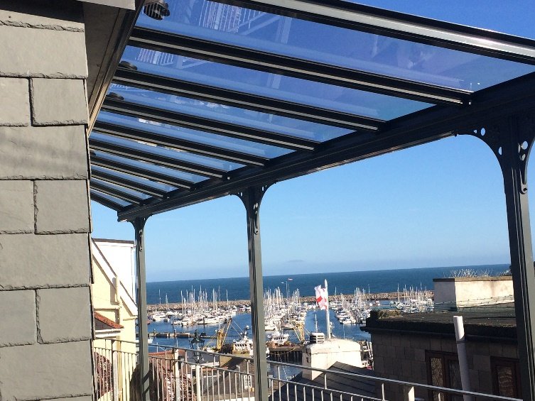

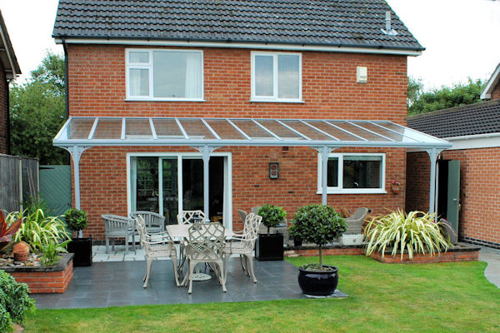

|  |  |  |
| --- | --- | --- |
| **5 of 5. Optional Extras** |  |  |

**The Victorian Upgrade**

The Victorian Upgrade can be added to the Simplicity 6 at an additional cost. This ornate upgrade consists of decorative, Victorian style post coverings that would fit in perfectly with traditional style buildings.

The Simplicity 6 can be transformed into a vintage canopy or carport with these ornamental post coverings which are manufactured from high grade Aluminium to match the Simplicity 6 frame.

These Victorian style posts coverings can be powder coated to any RAL colour.

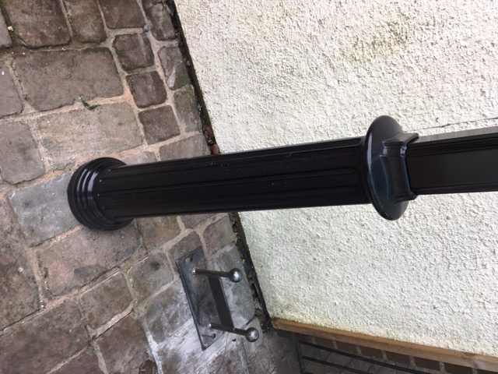

**Heaters & Lighting**

This integrated 12v LED light system is designed specifically for the simplicity 6, 35 and Alfresco, it’s designed to fit into the underside of the wall plate, the eaves beam and the glazing bar If required. Made from aluminium and polycarbonate they are strong and designed to last

The infrared wall mounted heaters have ceramic elements that are designed to gently warm adults and children whilst outdoors under a covered structure such as a canopy using Far Infrared technology which is completely harmless and contains no ultraviolet radiation or fumes. Freestanding options are also available.

 