To: |  | Quote No:
 |  | Job No:
Company:
 |  | Contents:
 |  | Page 1: | Product Image and Price
 |  | Page 2: | Technical Specification
 |  | Page 3: | Technical Drawings
 |  | Page 4: | Colour Options & Example
 |  | Page 5: | Optional Extras – The Victorian Upgrade
Date:

1 of 5. Product Image and Price

Quote to supply and install the Simplicity 16 with a 10-year guarantee as per specifications and installation information outlined on page 2.

System Size: <Length> metres x <Projection> metres

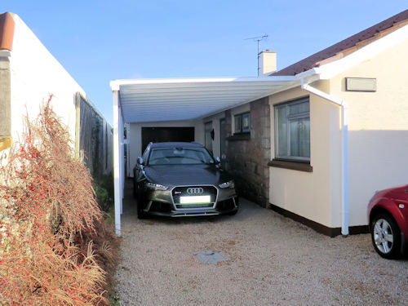 | 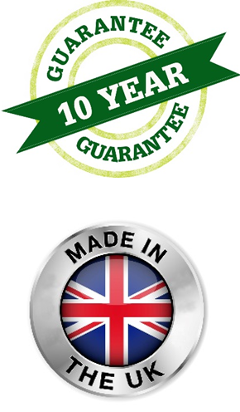
Total cost: £ + VAT
Payment terms:

2 of 5. Technical Specification

Item | Technical Specification
Roof Panels | 16mm thick structured polycarbonate with high UV protection. The panels are available in clear, opal, bronze and heat shield grey and offer the best insulation properties available (2.0 w/mk). They are block edged and are manufactured to the applicable size for the structure. This means that the edges are sealed and it also gives you much stronger roof sheets.
Posts | Posts are made from 75mm x 70mm Standard Posts or 70mm x 70mm Square Posts or 100mm x 70mm for a more chunkier look.
Framework | Aluminium framework is finished in white semi-gloss, anthracite grey fine textured and black fine textured as standard, however at an additional cost the framework can be powder coated to any RAL colour.
Weather Resistance | All structural components are made from aluminium for ultimate strength and total weather resistance. During the manufacture of our polycarbonate panels a layer of UV absorber is co-extruded onto the surface forming a barrier against UV radiation.
Method of Fixing | Back plate is fixed to wall/fascia, posts are fixed in ground.  Please note: If your building control or planning officer requires additional foundation mass or rainwater drainage over and above what has been quoted for, this will be at an additional cost to you. The Simplicity 16 roof structure is classed as fragile and is therefore not safe to be walked on as a means of escape.
Guttering & Downpipes | Integral aluminium guttering as standard, downpipes to be uPVC
Underground Drainage | Please review our terms and conditions.
Code 3 Lead Flashing | Lead flashing will be used wherever possible to seal the back of the structure. However, this is usually only possible where we can cut a groove into the material on which the carport will be fixed. On all other installations including fixing the back-plate across windows, “Flash-band” or “silicon sealant” may be used and in this case we cannot guarantee a watertight seal.
Excellent Fire Performance | Our structured polycarbonate roof sheets have been tested to most European standards & meet the BS476 part 7 with a class 1 fire rating and EN 13501 B-S1, d0.
Guarantee | The Simplicity 16 comes with a 10 year guarantee.
Life Expectancy | Up to a 60 years life expectancy depending on geographical locations and subject to the Maintenance Schedule.

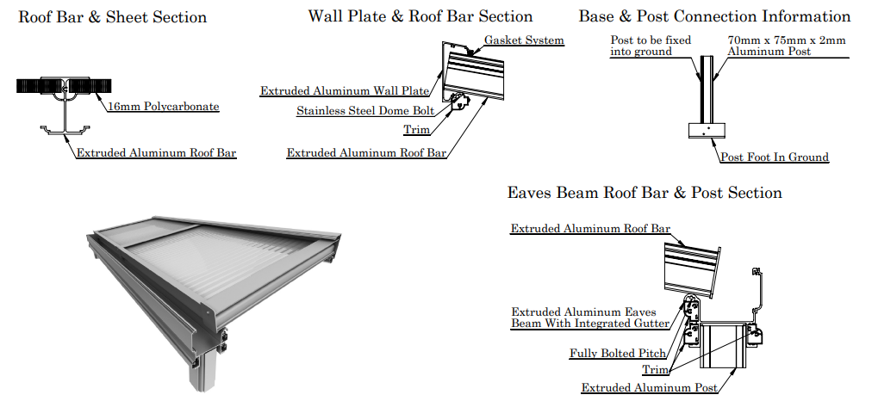

Please note:
- The height at the back of the structure is a maximum of 3.5 metres
- The height at the front of the structure is a maximum of 2.5 metres
- It is the customer’s responsibility to arrange for the removal of any items that may obstruct the structure unless prior arrangement has been made with us
- It is the customer’s responsibility to check whether planning permission and building regulations are required.
3 of 5. Technical Drawings

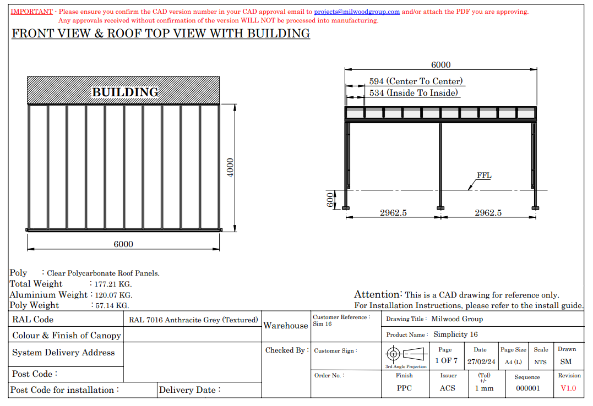

Information: Please note drawings are for illustration purposes only and are not to scale.

4 of 5. Colours Options & Example

RAL Colour Options

White Semi-Gloss,
Anthracite Grey Fine Textured
Black Fine Textured

5 of 5. Optional Extras

The Victorian Upgrade

The Victorian Upgrade can be added to the Simplicity 6 at an additional cost. This ornate upgrade consists of decorative, Victorian style post coverings that would fit in perfectly with traditional style buildings.

The Simplicity 6 can be transformed into a vintage canopy or carport with these ornamental post coverings which are manufactured from high grade Aluminium to match the Simplicity 6 frame.

These Victorian style posts coverings can be powder coated to any RAL colour.

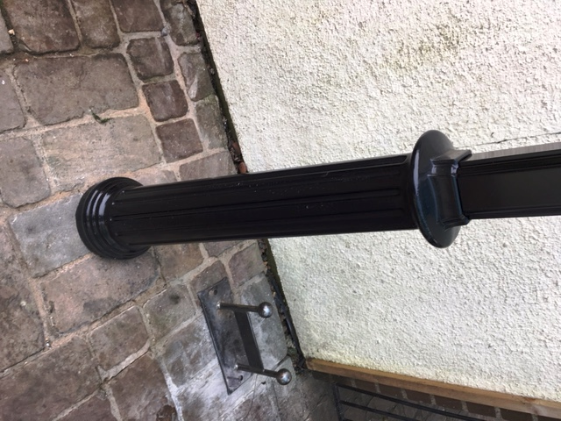
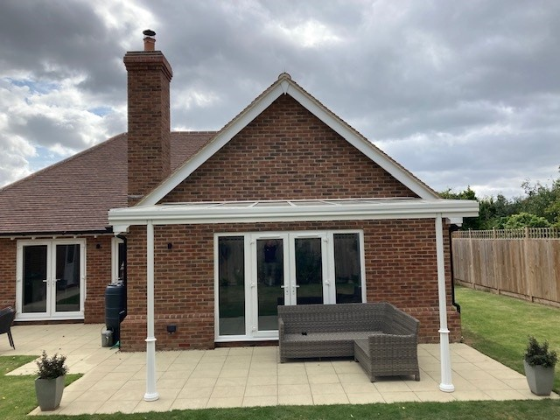

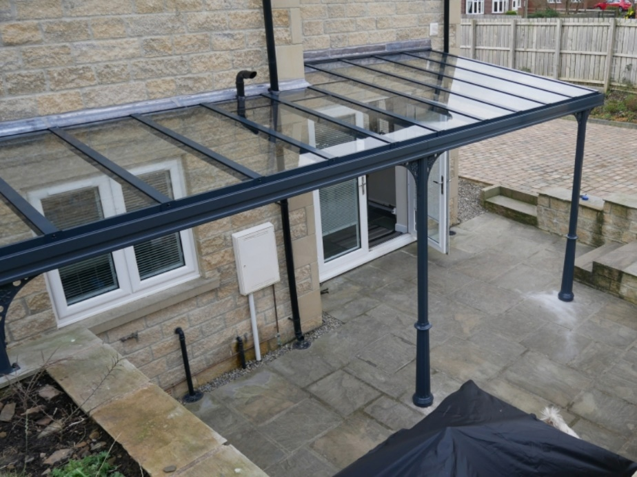

Heaters & Lighting

This integrated 12v LED light system is designed specifically for the simplicity 6, 35 and Alfresco, it’s designed to fit into the underside of the wall plate, the eaves beam and the glazing bar If required. Made from aluminium and polycarbonate they are strong and designed to last

The infrared wall mounted heaters have ceramic elements that are designed to gently warm adults and children whilst outdoors under a covered structure such as a canopy using Far Infrared technology which is completely harmless and contains no ultraviolet radiation or fumes. Freestanding options are also available.

