|  |  |  |  |
| --- | --- | --- | --- |
| **To:** | <First Name, Last Name> | **Quote No:**  **Job No:** | <Quote Number>  <Job Number> |
|  |  |  |  |
| **Company:** | <Company Name> |  |  |
|  | <Address Line 1> | **Contents:** |  |
|  | <Town> | **Page 1:** | Product Image and Price |
|  | <County> | **Page 2:** | Technical Specification |
|  | <Post Code> | **Page 3:** | Technical Drawings |
|  |  | **Page 4:** | Colour Options |
|  |  | **Page 5 & 6:** | Optional Extras |
| **Date:** | <Current Date> |  |  |

**1 of 5. Product Image and Price**

Quote to supply and install the **Contemporary Alfresco system** with a 10-year guarantee as per specifications and installation information outlined on page 2.

**System Size:** <Length> metres X <Projection> metres

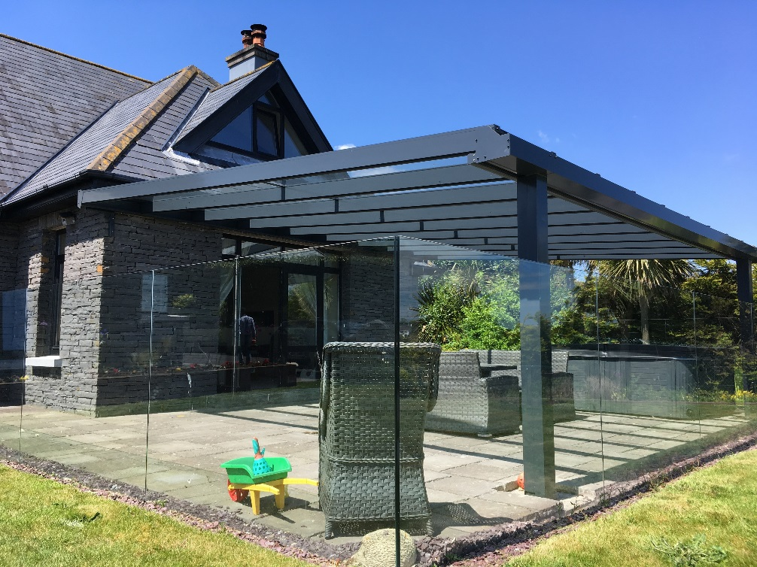

**Total cost: £<Cost> + VAT – Frame Colour:**

.

|  |  |  |
| --- | --- | --- |
| **2 of 5. Technical Specification** |  |  |

|  |  |
| --- | --- |
| **Item** | **Technical Specification** |
| **Roof Panels** | The Contemporary Alfresco is glazed 35mm Polycarbonate sheet. The glass option provides high light transmission for outstanding visual clarity ensuring an unrestricted view.Our 35mm thick polycarbonate panels are light in weight, up to 200 times stronger than glass with high UV protection. The panels are available in clear and opal and offer the best insulation properties available (1.2 w/mk). They are block edged and are manufactured to the applicable size, ready to be installed into the Contemporary Alfresco. This means that the edges are sealed and it also gives you much stronger roof sheets. |
| **Posts** | Posts are made from 150mm x 150mm aluminium box section, which are either bolted to a base or cast into foundation – size subject to structural engineer’s report. |
| **Framework** | The aluminium can be powder coated to any RAL colour at an extra cost. Standard Colour is Anthracite Grey. The system incorporates integrated down pipes and easy-fix ornate aluminium claddings. |
| **Weather Resistance** | All structural components are made from aluminium for ultimate strength and total weather resistance. |
| **Method of Fixing** | The back plate is fixed to wall/fascia. Pitch 5 to 45 degrees.The Contemporary Alfresco glass roof structure is classed as fragile and therefore is not safe to be walked on as a means of escape. The 35mm polycarbonate roof option is Class A non-fragile and has been independently tested - Fragility report available on request. |
| **Guttering & Downpipes** | Discrete integral aluminium guttering as standard |
| **Code 3 Lead Flashing** | Lead flashing will be used wherever possible to seal the back of the structure. However, this is usually only possible where we can cut a groove into the material on which the structure will be fixed. On all other installations including fixing the back-plate across windows, “Flash-band” or “silicon sealant” may be used and in this case we cannot guarantee a watertight seal. |
| **Guarantee** | The Contemporary Alfresco is supplied with a 10 year guarantee. |
| **Life Expectancy** | Up to 60 years life expectancy depending on geographical locations and subject to the Maintenance Schedule. |

Please note:

* The height at the back of the structure is a minimum of 2.5 metres (Depending on projection)
* The height at the front of the structure is a minimum of 2.1 metres (Depending on projection)
* It is the customer’s responsibility to arrange for the removal of any items that may obstruct the structure unless prior arrangement has been made with us
* It is the customer’s responsibility to check whether planning permission and building regulations are required.

|  |  |  |
| --- | --- | --- |
| **3 of 5. Technical Drawings** |  |  |

**Please note**: drawings are for illustration purposes only and are not to scale**.**

|  |  |
| --- | --- |
| **Perspective View** |  |
|  |  |

|  |  |  |
| --- | --- | --- |
| **4 of 5. Colour Options** |  |  |

**RAL colour options**

Standard colour is Anthracite Grey.

|  |  |  |
| --- | --- | --- |
| **5 of 6. Optional Extras** |  |  |

**Heaters & Lighting**

This integrated 12v LED light system is designed specifically for the simplicity 6, 35 and Alfresco, it’s designed to fit into the underside of the wall plate, the eaves beam and the glazing bar If required. Made from aluminium and polycarbonate they are strong and designed to last

The infrared wall mounted heaters have ceramic elements that are designed to gently warm adults and children whilst outdoors under a covered structure such as a canopy using Far Infrared technology which is completely harmless and contains no ultraviolet radiation or fumes. Freestanding options are also available.

**Integrated Lighting**

The system also has the flexibility to include integral LED lighting at an extra cost.

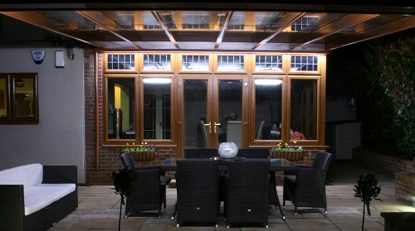

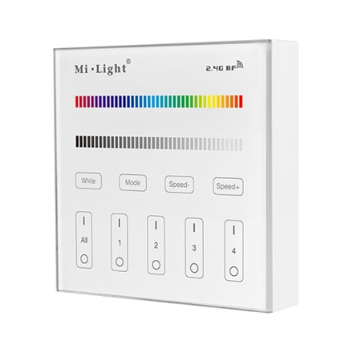 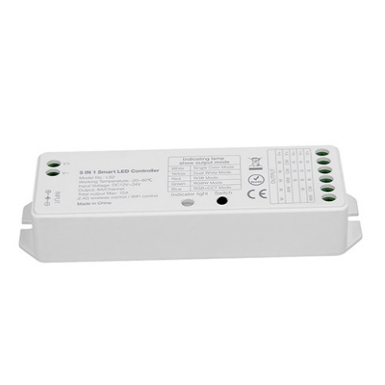

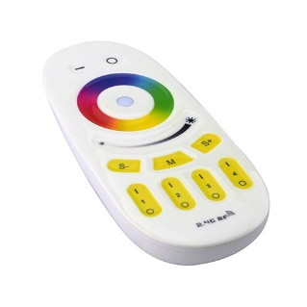

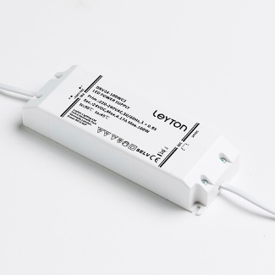 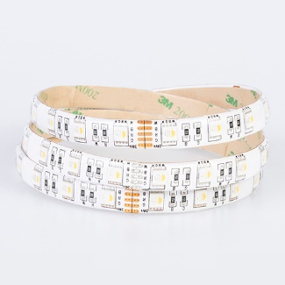

**6 of 6. Optional Extras**

**Glass Room Upgrade: Sliding Glass Doors**

Glass sides can also be added as well as sliding doors to provide enclosed, ultimate all-weather protection at an additional cost.

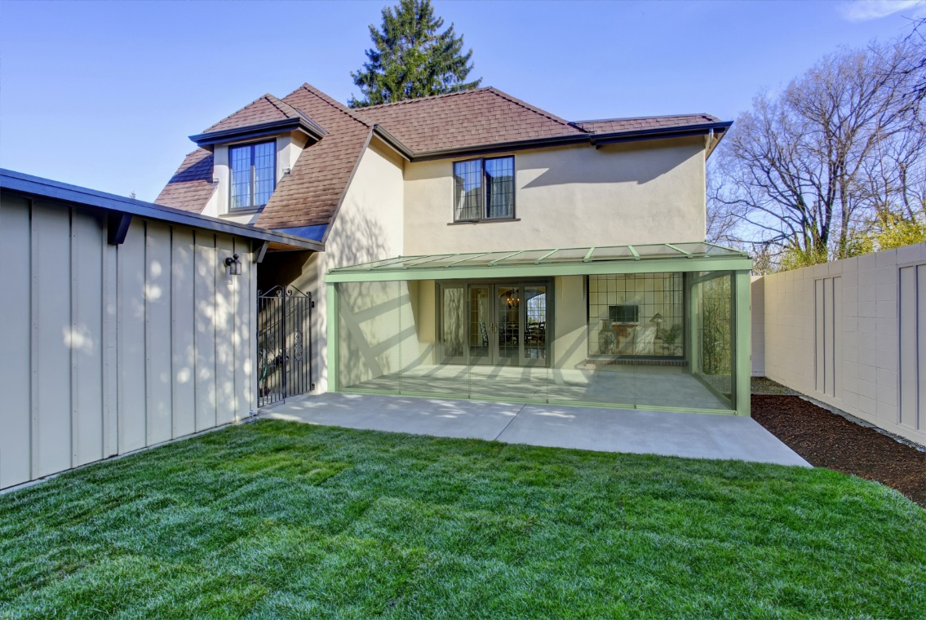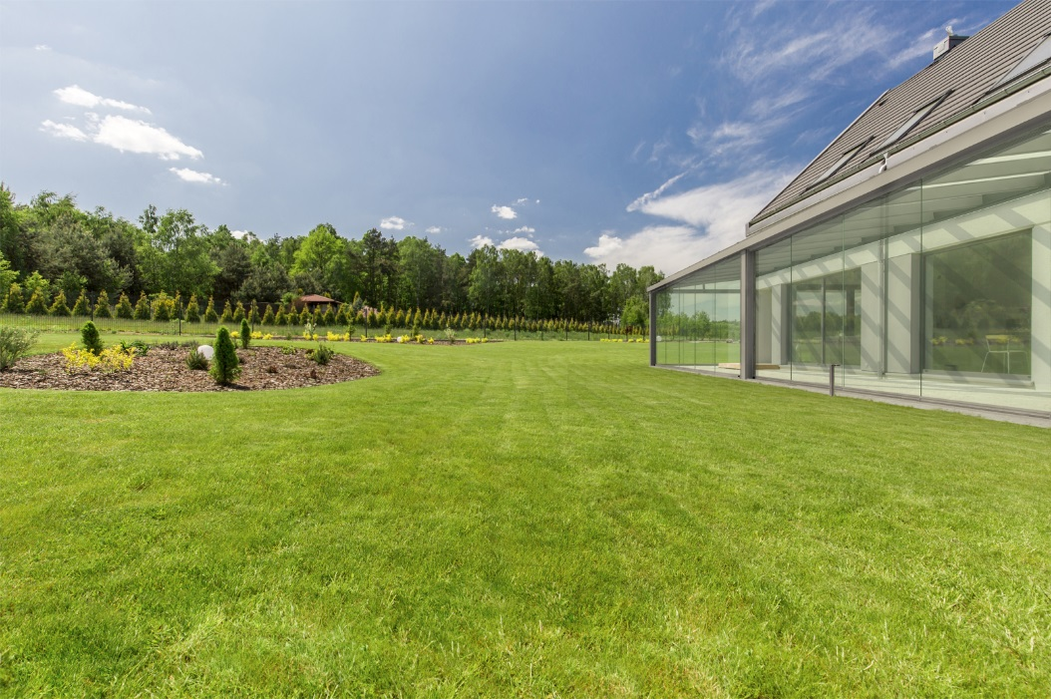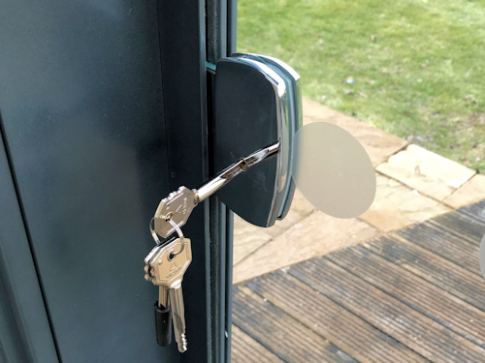

**Screener Veranda**

Add blinds to the roof of your Contemporary Alfresco with the Screener Veranda.

